
MODULE NAME: | MODULE CODE:
OPEN SOURCE CODING | OPSC6311
ASSESSMENT TYPE: | POE ( PART 1)
TOTAL MARK ALLOCATION: | 100 MARKS
TOTAL HOURS: | 21 HOURS
STUDENT NAMES: | Zesande Mbekwa ST10389901  Olothando Hoyi ST10201134  Okuhle Dyasi ST10328333  Athenkosi Sonakile ST10220864
LECTURERS NAME: | Elisha Agoni
DATE: | 02 April 2025

Table of Contents
Research Introduction 3
Strengths 9
Weaknesses 9
App Two: NerdWallet 10
NerdWallet Weaknesses 12
Innovative Features of NerdWallet 12
App Three: Wallet by Budget Bakers Overview 14
Strengths: 21
Weaknesses: 21
Best Features to Add on our Application: 22
Conclusion 23
Overview of the App 24
Innovative Features: 24
Detailed List of Requirements 24
User Personas & Accessibility Considerations To ensure the app meets the needs of diverse users, we have developed the following personas: 25
Accessibility considerations include: 26
Competitive Analysis Analyzing existing budgeting apps such as Mint, YNAB, and 26
User Interface Design & Navigation The app consists of the following screens: 26
User Interface Design for our App 27
Work Breakdown 43

Research
Introduction
In today's fast-traditional digital world, effectively managing personal finance has become a priority for individuals seeking financial stability and development. With the rise of technology, individual budget applications have emerged as essential tools that help users to track expenses, determine financial goals and make informed financial decisions. This research discovers three widely used individual budget applications - NerdWallet, Smart Wallet, and Wallet by BudgetBaker - to analyze their features, purpose and effectiveness in assisting users with financial management. By comparing these applications, the purpose of this study is to provide insight into its strength and limitations, eventually users to help make an alternative when selecting a budget tool that suits their financial needs.
App One: Smart Budget
Overview
Smart Budget is a personal finance app that helps users track expenses, manage multiple accounts, and set financial goals. It’s packed with useful features like real-time balance updates, expense tracking, budget limits, and savings goals. The app is available in multiple languages and offers a clean, user-friendly interface for managing money more effectively.
Screenshots and Feature Breakdown
Account Setup:
These screens appear during the setup process. Users choose a currency, name their account, and set an initial savings goal before reaching the main dashboard.
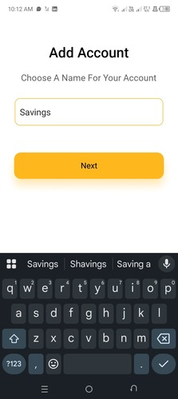
Home Dashboard:
Once the initial setup is done, users land on the home screen. It gives a quick overview of balances and spending, making it easy to keep track of finances.
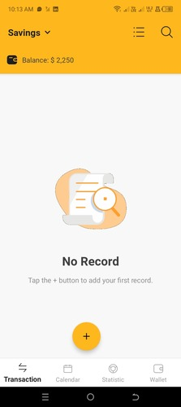
Adding a Transaction (Income, Expense, Transfer):
Pressing the plus icon takes users to a screen where they can add records for income, expenses, and transfers. The only real difference between them is that transfers include a "To Wallet" field to select where the money is going.
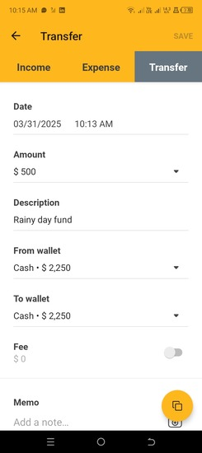
Statistics Tab:
This tab breaks down spending by month, showing where money is going. The visual charts make it easier to understand financial patterns.
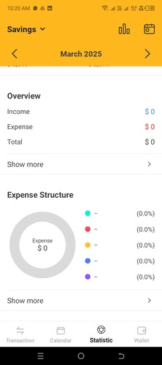
Calendar Tab:
The calendar view shows a summary of income, expenses, and transfers for a selected month. This is helpful for spotting trends and adjusting your spending habits.
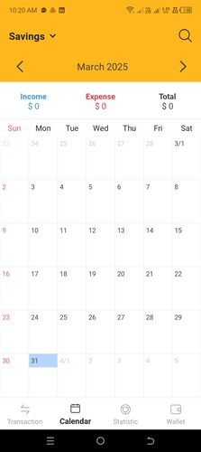

Wallet Tab:
This tab lets users manage multiple wallets (accounts) and access extra features like savings goals, debt tracking, and recurring payments. It’s a great way to keep track of different types of finances in one place
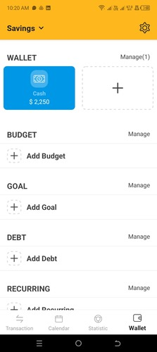

Strengths
User-Friendly & Easy to Navigate – The interface is clean and well-organized, making it simple to track expenses and income.
Multiple Wallets for Better Organization – Users can separate finances for personal, business, or family use.
Budgeting Tools – The app allows users to set spending limits and receive alerts when they’re close to exceeding them.
Great Statistics – Spending trends, graphs, and the calendar view make it easy to spot financial habits and plan better.
Multi-Language Support – Available in various languages, making it accessible to a wider audience.
Security Features – Includes a 4-digit PIN for extra protection.

Weaknesses
Limited Cross-Platform Support – The app is only available on Android. Expanding to iOS and a web version would attract more users.
Subscription Model Could Offer More Features – Right now, the paid version only removes ads. Adding premium features like bank syncing, advanced reports, or custom notifications could make an ongoing subscription more appealing

Innovative Features
Recurring Transactions – Automates fixed expenses or income, saving users time.
Export & Backup Options – Users can back up data and export reports in different formats for record-keeping.
App Two: NerdWallet
Overview
NerdWallet is a financial technique "Fintech" company that provides equipment, advice and comparison to help consumers to make better financial decisions. The platform has a wide range of financial disciplines including credit cards, loans, banking, investment, mortgage, insurance and small business finance. The goal of NerdWallet is to simplify financial decisions by offering the guide, calculator and easy to understand the comparison of the product. It works as a joint marketing platform, when users sign up for financial products through their recommendations, the commission earns.
Financial Equipment: Calculator for Budget, Horticulture Payment, Debt Payment and Credit Card Award.
Product Comparison: Intensive reviews and comparison of financial products such as credit cards, bank accounts and insurance policies.
Expert guidance: Articles, blogs and resources that explain complex financial subjects in easily understanding language. Personal recommendations: User's suit advice based on financial profiles and goals.
Tax credits and deductions:
With NerdWallet, you get to learn about 22 popular tax deductions and tax breaks. As a new income earner you won’t struggle when using NerdWallet you will be helped budget wisely.
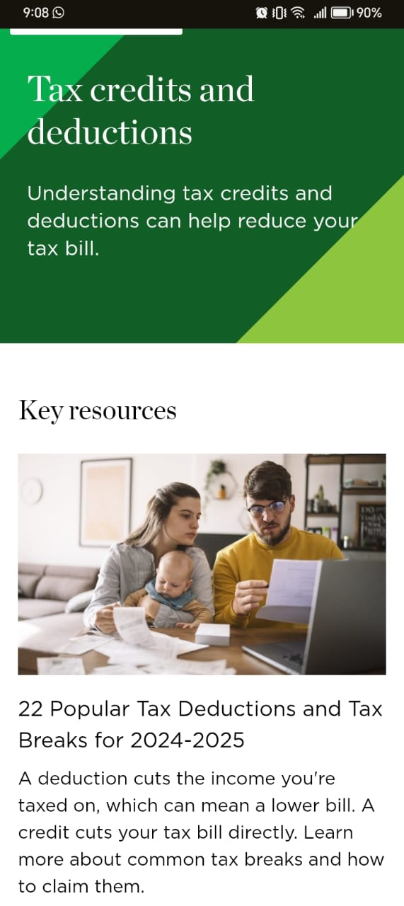
Mortgages page:
NerdWallet has a mortgage page where a new or current income earner can see and compare mortgage rates. They can find the lowest rates using NerdWallet expertise.
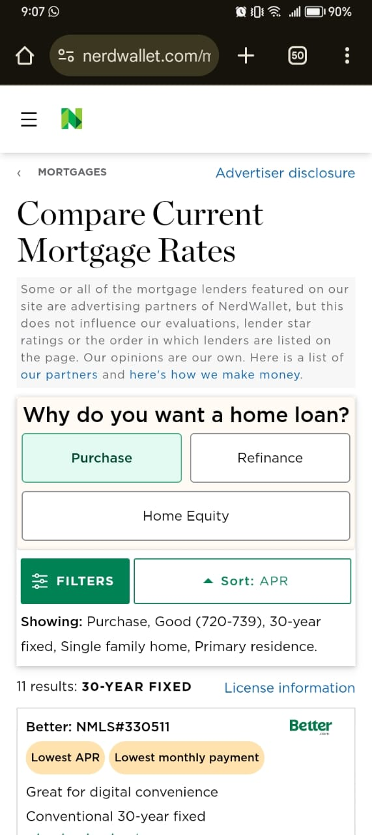
Credit page:
Things such as credit card bonuses, balance transfer credit cards, best travel cards, NerdWallet offers best advice to those. You get to be shown recommendations and compare credit cards.
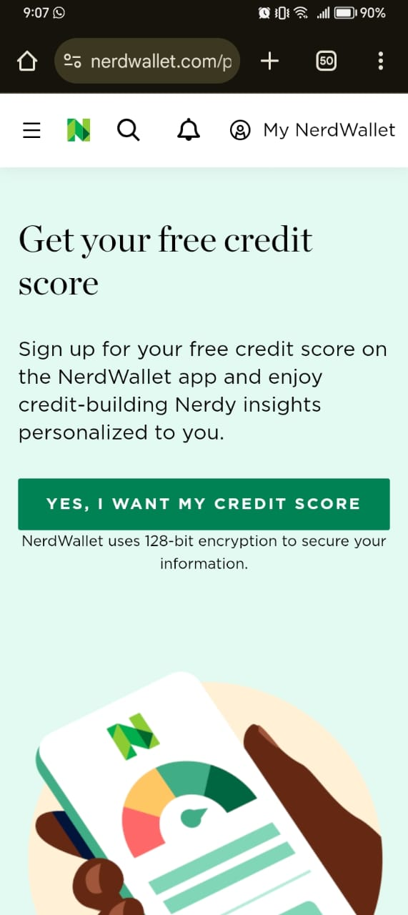
NerdWallet Strengths
Comprehensive Financial Information: NerdWallet provides intensive guides, reviews and comparison tools in many financial categories.
User -friendly interface: The platform is made accessible to all users, even with low financial knowledge.
Independent to use: Users can use all materials and equipment for free, making it a valuable resource for budget-conscious individuals.
Wide range of financial equipment: NerdWallet provides a calculator for mortgage, loan, credit card awards and savings, which helps users to make informed financial decisions.
Personal recommendations: By inputting financial statements, users can get customized recommendations for credit cards, loans and other financial products.
NerdWallet Weaknesses
Affiliate Marketing Bias: Since NerdWallet acquires commission from financial institutions, its recommendations may prioritize financial products participating on potentially better options.
Limited coverage of niche financial products: While it covers a wide range of subjects, some niche or special financial products cannot be done well.

Innovative Features of NerdWallet
NerdWallet App with Smart Financial Tracking
All-in-One Finance Dashboard: The mobile app allows users to track their financial accounts bank accounts, credit cards, loans in one place.
Spending Analysis & Budgeting Tools: The app categorizes transactions to help users manage their money effectively.
Credit Score Monitoring: Provides free credit score updates and personalized tips to improve credit health.
Smart Financial Tools & Calculators
Loan and Mortgage Calculators: Users can calculate loan repayments, interest costs, and affordability scenarios.
Credit Card Comparison Tool: A powerful tool that allows users to compare rewards, APRs, and fees based on their spending habits.
Savings & Budgeting Calculators: Helps users track spending, set financial goals, and optimize their budget.

App Three: Wallet by Budget Bakers
Overview
Wallet by Budget Bakers is a comprehensive personal finance management app designed to help users efficiently track their daily expenditures, manage budgets, and gain valuable insights into their financial health. Whether you’re looking to monitor credit card spending, track savings, or manage investments, this app offers a streamlined and intuitive approach to achieving financial goals.
Sign Up Page:
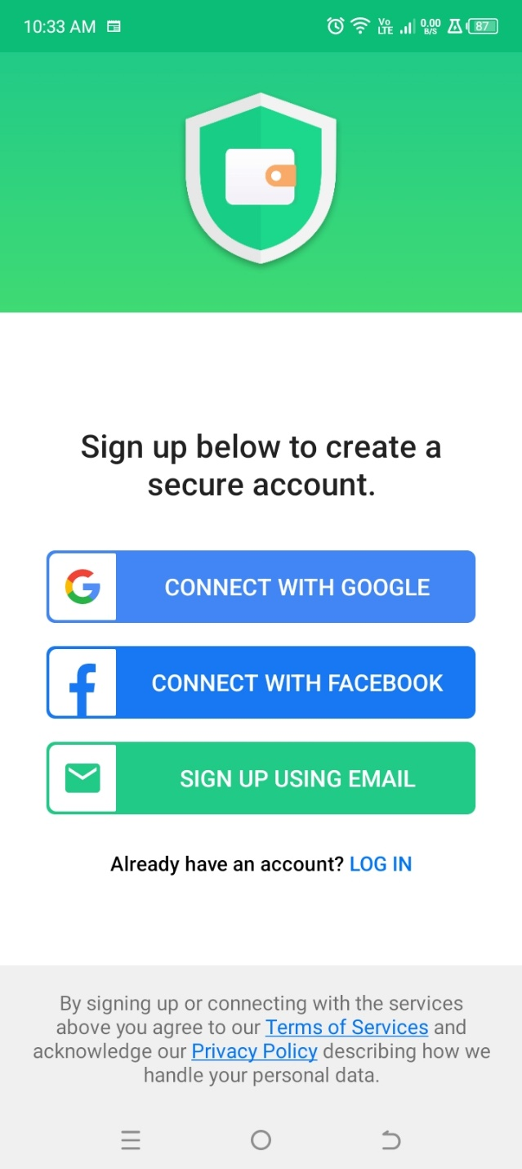

Home Page:
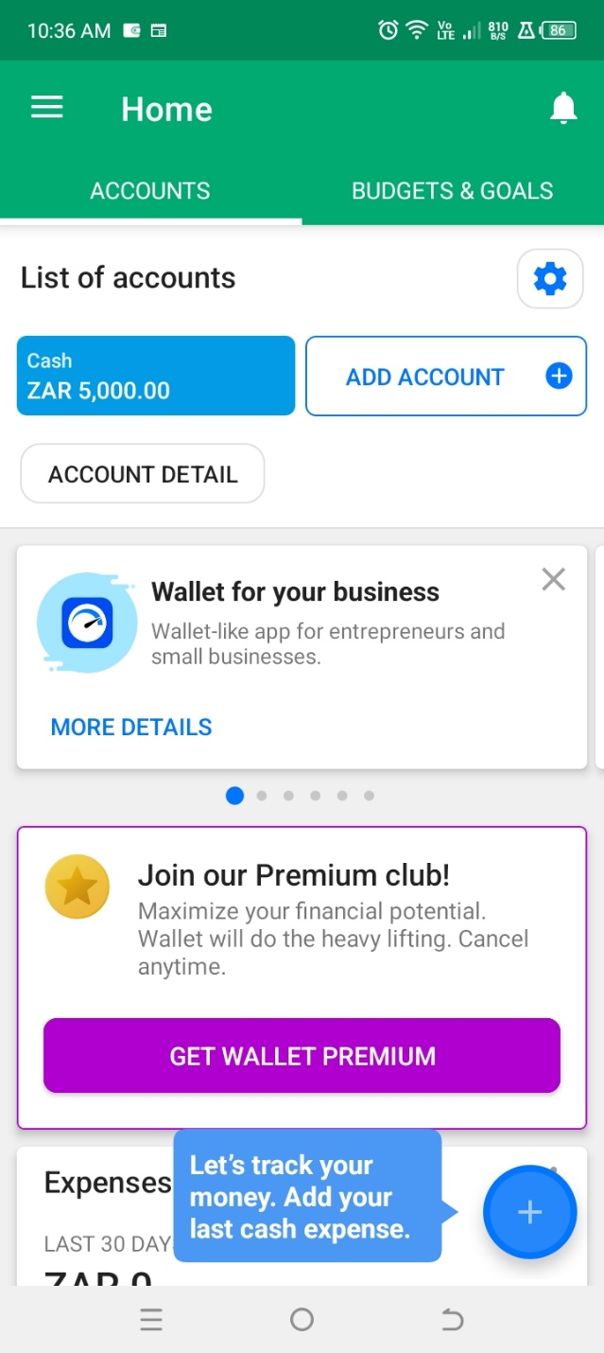

Add Expense Page:
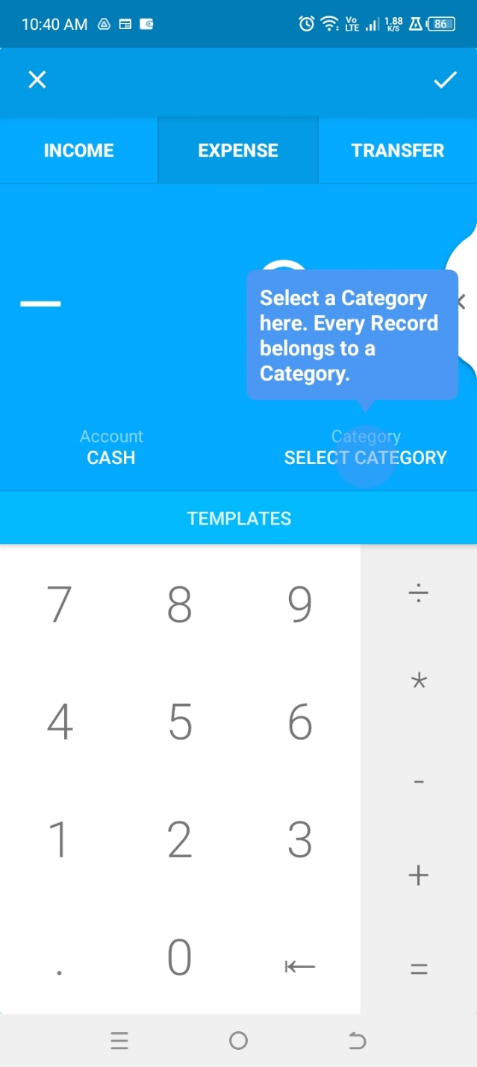

Accounts Page:
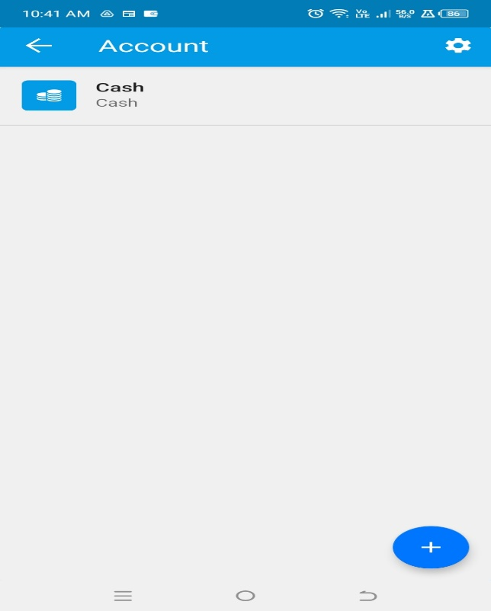

Add Account page:
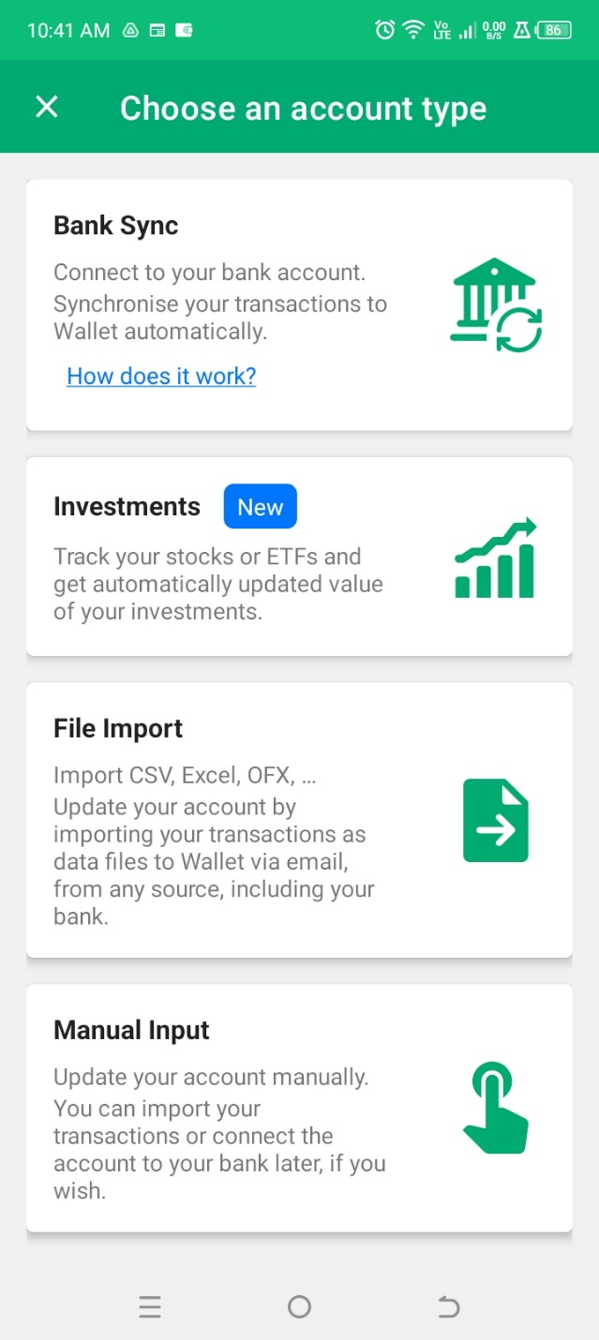

Analytics Page
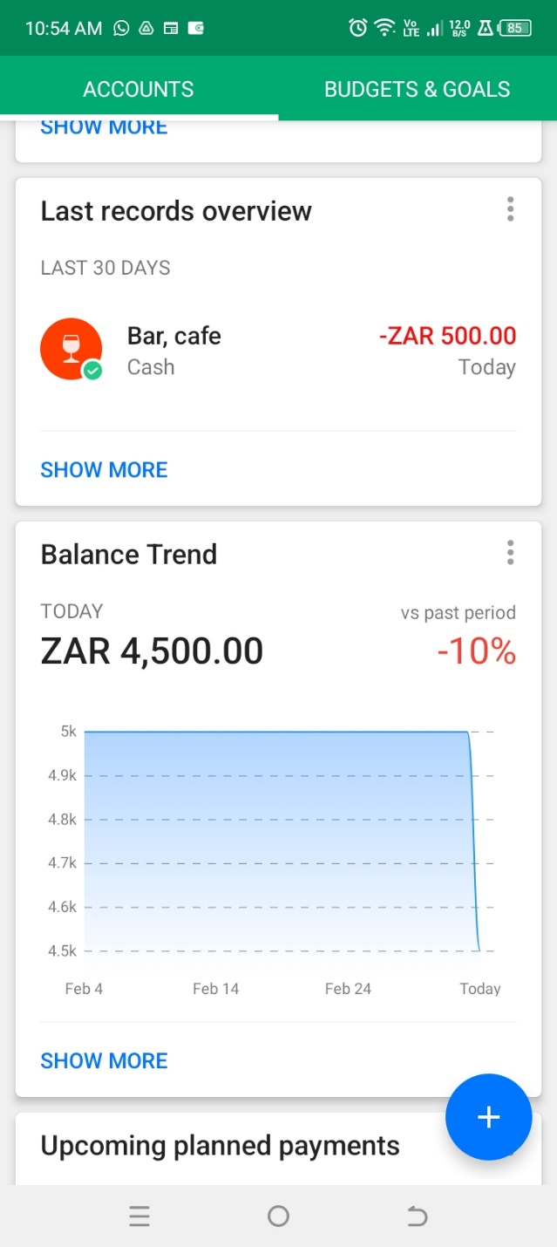
Features:
Customizable Account Setup:
- Easily add and manage multiple accounts such as savings, debit, and credit cards, with options for manual input or bank syncing.
- Users can personalize account types and categories to suit their individual needs.
Expense Tracking & Budget Planning:
- Track daily, weekly, and monthly spending with the ability to set specific budgets for categories like food, transportation, and entertainment.
- Notifications alert users when they are close to exceeding their budget, helping maintain financial discipline.
Transaction Categorization & Labels:
- Categorize expenses into customizable categories such as groceries, social meals, work expenses, and more.
- Apply labels to specific transactions (e.g., insurance premiums or work claims) for better tracking and reporting.
Credit Card Management & Cashback Maximization:
- Track credit card spending with detailed breakdowns by payment types (e.g., mobile contactless, online payments).
- Maximize cashback rewards by categorizing spending effectively to meet credit card spending criteria.
Investment Tracking:
- Record deposits into investment accounts, such as SafeTrade, and track them manually for better financial oversight.
- While the app doesn't track real-time market fluctuations, it helps monitor capital contributions.
Detailed Analytics & Reports:
- Access powerful, easy-to-read financial reports with the option to filter by date range or specific categories.
- Visualize spending trends with detailed graphs and downloadable reports in CSV or XLS formats.
Mobile & Desktop Integration:
- Available on both mobile and desktop platforms, offering a seamless user experience and access to real-time data on the go.
- The desktop version allows for more detailed analytics and filtering options, providing deeper insights into financial patterns.

Strengths:
- Highly Customizable: Offers extensive flexibility for users to set up categories, accounts, and labels according to their unique financial needs.
- Mobile Convenience: Easy-to-use mobile app that makes tracking expenses and managing budgets effortless on the go.
- Credit Card & Cashback Optimization: Ideal for users looking to track credit card spending and maximize cashback rewards.
- Comprehensive Financial Overview: Consolidates all personal finance data in one place for easy access and detailed insights.
- Advanced Reporting & Analytics: Offers powerful tools to filter and analyze spending over specific time periods.

Weaknesses:
- No Real-Time Investment Tracking: While the app is great for managing capital, it doesn’t track real-time market changes or provide automatic updates for investments.
- Manual Entry Requirement for Some Users: Bank syncing is optional, and some users may find manual data entry cumbersome compared to fully automated options.
- Limited Free Features: The free version is limited in terms of the number of accounts that can be tracked, which may not be sufficient for those with complex financial setups.
Visual Infographic of all three apps
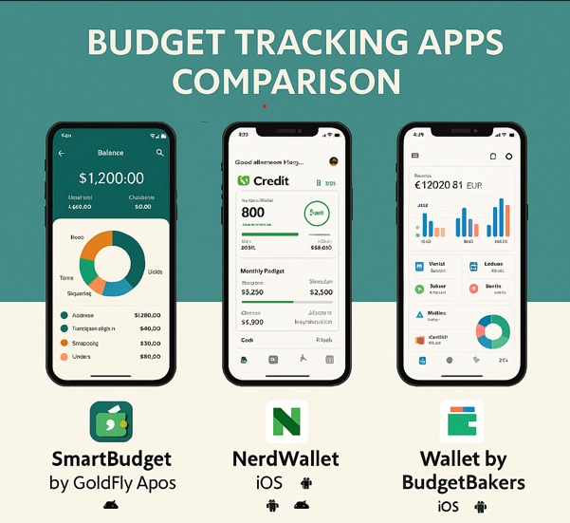

Best Features to Add on our Application:
- Real-Time Investment Tracking: Integration with investment platforms to automatically track portfolio performance and fluctuations.
- Automatic Expense Recognition: Enhanced AI to automatically categorize transactions and recognize recurring expenses without manual input.
- Shared Account Tracking: More robust features for families or teams to collaborate on financial goals and budgeting in a shared environment.

Conclusion
Effective personal budget is important for financial stability, and the use of budget applications has simplified this process for many individuals. This research examined NerdWallet’s, Smart Wallets and Wallets by BudgetBackers, which highlight their main features, purpose and overall effectiveness. Each of these applications provides unique functionality to suit various financial requirements, ranging from expenditure tracking and budget equipment to financial insights and target-provision facilities. While NerdWallet stands out for its comprehensive financial guidance and credit score tracking, Smart Wallet Excel in user-friendly design and AI-driven expenditure management. On the other hand, the wallet provides strong synchronization capabilities and advanced financial planning equipment by the budget bakers. Ultimately, the best option depends on individual financial goals and preferences. By taking advantage of these budget applications, users can gain better control over their finance, develop disciplined spending habits, and work towards long -term financial well -being. As technology develops, the individual finance apps will probably become even more advanced, making individuals the way they manage their money.
Planning and Design
Introduction
This document presents the design and project plan for a Budget Management App. The purpose of the app is to help users track expenses, filter transactions, upload receipts, and analyze spending habits. The design is based on user research to ensure a user-friendly experience that meets financial management needs.
Managing personal finances effectively is essential for financial stability. This app is designed to simplify budgeting by offering features that streamline expense tracking and financial analysis. By integrating intuitive UI components, automation, and analytics, users will be empowered to make better financial decisions.
Overview of the App
App Name: Financial App
App Icon Design: A minimalistic wallet with a checkmark, symbolizing financial control.

Innovative Features:
Interactive date filters for tracking expenses.
Receipt upload functionality.
Expense categorization.
Data export and analysis tools.
Gamification elements such as achievement badges for savings.
AI-powered financial insights based on spending patterns.
Secure cloud backup for financial data.
Voice input for quick expense logging.
Multi-device synchronization.
Subscription-based premium features for advanced analytics.
Integration with bank APIs for automatic expense tracking.

Detailed List of Requirements
User Authentication: Secure login and signup process with email or social media authentication.
Expense Tracking: Users can enter, edit, and delete transactions with options to add descriptions and attach receipts.
Date Filtering: Select a date range to filter financial records and generate reports for specific periods.
Receipt Upload: Take a photo or upload a receipt as proof of purchase, with automatic text recognition for key details.
Categorization: Transactions categorized (e.g., Groceries, Transport, Entertainment) with AI-based autosuggestion.
Data Export: Ability to download reports in CSV or PDF format for offline record-keeping.
Dashboard: Overview of total planned expenses, savings, and spending trends with visual charts and graphs.
User-Friendly Navigation: Smooth navigation using bottom menu tabs with quick access to primary features.
Notifications & Reminders: Automated alerts for due payments, low budget warnings, and savings goals.
Cloud Backup: Ensure financial data is safely stored and accessible across multiple devices.
Multi-Language Support: Available in multiple languages to cater to a global audience.
Dark Mode: A visually appealing dark theme to reduce eye strain for users.
AI-Based Insights: Analyzes spending habits and suggests cost-cutting measures and budgeting tips.
Offline Mode: Enables basic functionality without internet access, syncing data once reconnected.
Bank Integration: Securely connect to bank accounts to automate transaction logging and avoid manual data entry.
Subscription Plans: A free version with essential features and a premium version for advanced analytics and AI-driven budgeting recommendations.

User Personas & Accessibility Considerations To ensure the app meets the needs of diverse users, we have developed the following personas:
Emma (Young Professional, 26 years old): Needs an easy way to track expenses and save money for future investments.
James (Freelancer, 34 years old): Requires advanced tracking and AI insights to manage fluctuating income streams.
Zesande (Retired, 60 years old): Prefers a simplified UI with clear fonts and voice commands for easier interaction.

Accessibility considerations include:
High contrast mode for visually impaired users.
Voice input for users with motor disabilities.
Large, easy-to-read text options.
Simple navigation for seniors.
Competitive Analysis Analyzing existing budgeting apps such as Mint, YNAB, and Pocket Guard, Smart Budget Tracker differentiates itself by:
Offering AI-driven insights tailored to spending habits.
Providing multi-device synchronization and cloud backup for data security.
Integrating with bank APIs for automated expense tracking.
Including gamification elements to encourage savings.
Supporting offline functionality, allowing expense tracking without an internet connection.

User Interface Design & Navigation The app consists of the following screens:
Home Screen: Overview of financial summary and quick access to features.
Filter Screen: Users can select a date range and category to filter expenses and generate reports.
Upload Receipt Screen: Users can upload proof of expenses and auto-extract data from receipts.
Analysis Screen: Displays spending trends, comparison charts, and AI-driven financial insights.
Settings Screen: Allows users to customize notifications, backup preferences, and UI themes.
Profile Screen: Provides user information, subscription plans, and account settings.
User Interface Design for our App
Splash Screen
Purpose: The splash screen acts as a landing page of the application when a user clicks at the app to use it, also displaying the logo and colors of the app for about 5 seconds.
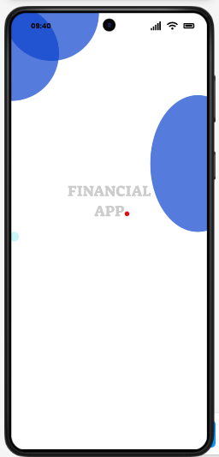

Login Screen
Purpose: After about 5 seconds of displaying the splash screen, the app redirects to the login page, were user’s with an already existing account can login by entering their creditials (username and password), or if a user does not have an account there is a link available that redirects a user to the registration page when pressed.
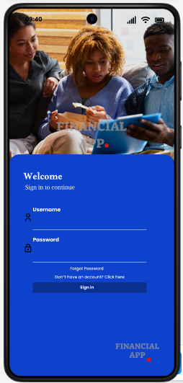

Registration Page
Purpose: After a user press the “Don’t have an account? Click here” link they are redirected to the registration page where a user is prompted to fill in all required fields to successfully create an account, if a user does not follow standards for creating an account properly an error message appears that prompt a user to enter a required format.
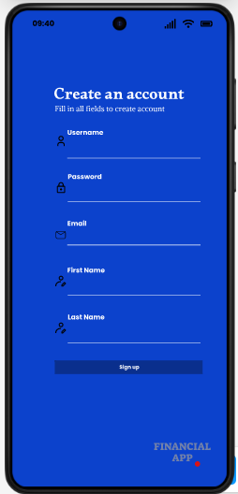

Home Screen
Purpose: After a user has succesfully loggined they are redirected to their home screen that features an welcome message followed by their name and surname and optionally a user can add a profile picture, this creates trust to users that this is indeed their account and have successfully loggined in, the home screen also includes a category bar that shows the number of categories the user has and below is a recent expense tracker that shows the most recent expense transaction.
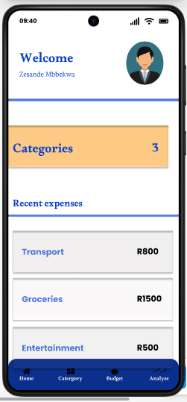
Category Management Screen
Purpose: The “Category Management Screen” feature a CRUD system to maniplulate the data, user’s can add new categories, edit existing categories and delete categories.
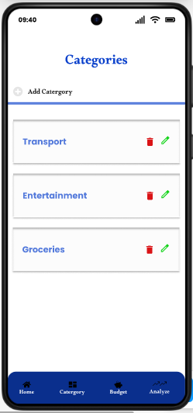

Add new Category Screen
Purpose: When a user presses the “add catgory” icon on the “Category Management Screen”, and Iframe pops up which allow a user to input the new category name and add it.
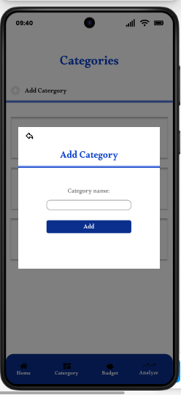

Budget Management Screen
Purpose: The “Budget Management Screen" includes option for users to enter a monthly budget amount which then is displayed on the “Your Budget: R ‘budget entered’”, and a users can then add expense by following all required proccesses to add an expense, the amount then is accumulated on the “Total Planned expense:” with rest of other expenses, after that the range goes up on the circle which is the volume of your monthly budgte set, when its full it means your budget has been reached
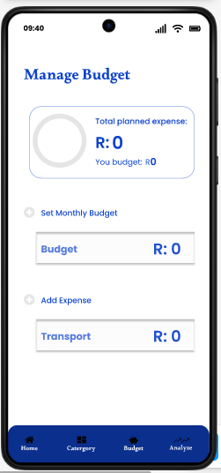

Set Monthly Budget Screen
Purpose: When a user presses the “set monthly budget” icon this iframe pops up which promtps a user to enter an amount to set the budget, if a user enters a non-numeric value a error message is displayed.

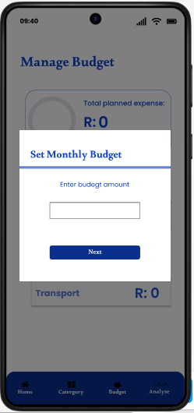

Pick Category Screen
Purpose: After a user enters the budget amount they are promted to pick categories which they would like to set a limit for.

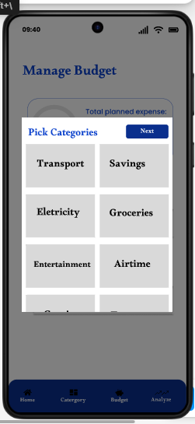

Set Limit Screen
Purpose: After a user has selected all categories they require for the monthly budget, they are promtped to set a limit for each of their selected categories.
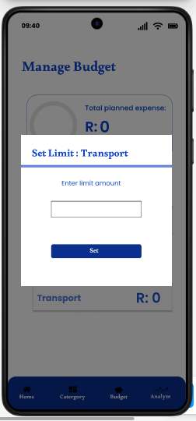

Enter Expense Amount Screen
Purpose: When a user presses the “add expense icon” this iframe pops up that propts a user to enter a expense amount, if the value entered is not numerica a error message is displayed.

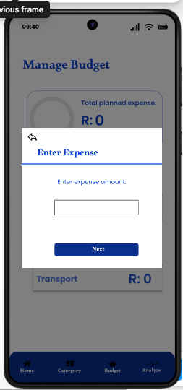

Select Category
Purpose: After a user inputs expense amount, this screen pops up next which consists of a drop down menu for users to select the category for this expense
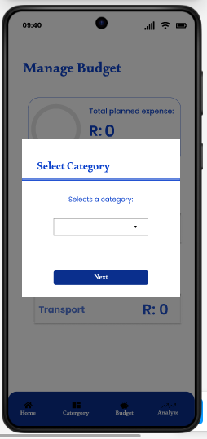

Enter Description Screen
Purpose: After selecting a category for the expense this screen pops up which requires a user to enter a description for their expense.
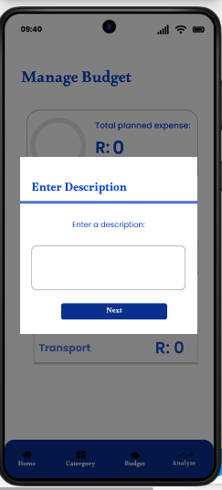

Select Date Screen
Purpose: After a user enters a description for the expense, this screen pops up which require a user to select a date for the expense tranaction.
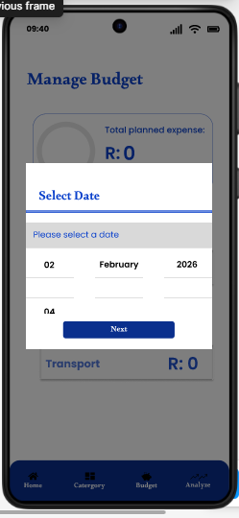

Upload Recipt Screen
Purpose: After a user selects a date for the expense tranaction this screen pops up that optionally allows a user to upload an recipt for the expense or they can otionally skip it then the expense has been successfully done.
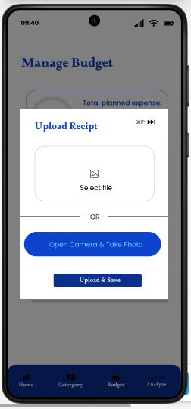

Filter Screen
Purpose: This screen features a drop down option which allows a user to filter either saving expenses nor expenses, then a user can press the “select rom date” icon then a iframe pops up that requires a user to select a from date, then the same for the “to date” then when a users presses the filter button the results are displayed
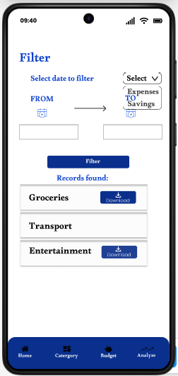
Work Breakdown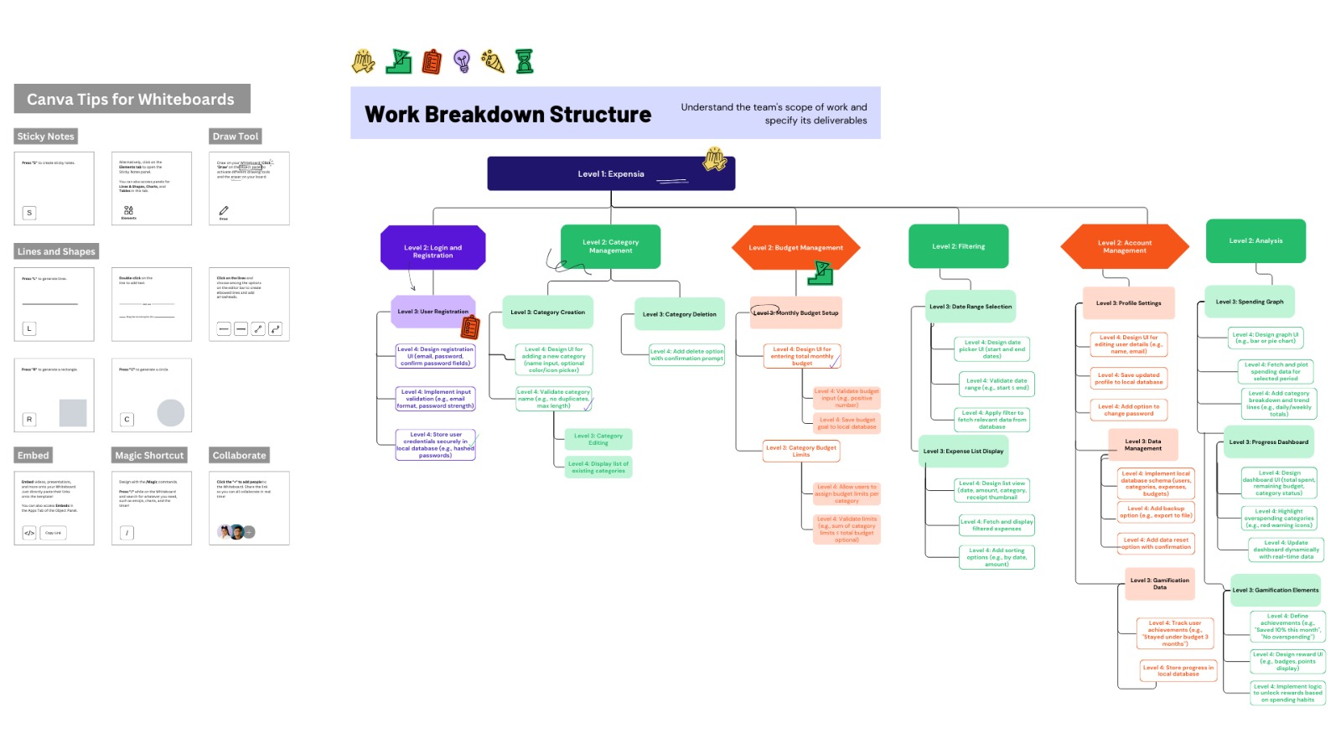
Conclusion
This project plan outlines the complete design and development approach for the Smart Budget Tracker. The app will provide an intuitive, seamless, and effective financial management experience for users. With its innovative features such as AI-powered insights, automated categorization, and gamification, this app goes beyond basic budgeting tools to create a holistic financial management solution.
By carefully planning the implementation stages and ensuring thorough testing, the app aims to deliver a high-quality, stable, and secure user experience. The combination of cloud backup, offline mode, and multi-device synchronization ensures that users can access their financial data anytime, anywhere.

